
Dashboard Design

Team ID | MCA
Project Name | Online Learning Engagement and Student Performance Analysis
Maximum Marks | 5 Marks

Creating an effective dashboard involves thoughtful design to ensure that the presented information is clear, relevant, and easily understandable for the intended audience. Here are some key principles and best practices for dashboard design
Activity 1: Interactive and visually appealing dashboards
Creating interactive and visually appealing dashboards involves a combination of thoughtful design, effective use of visual elements, and the incorporation of interactive features. Here are some tips to help you design dashboards that are both visually appealing and engaging for users so take care of below points
- Clear and Intuitive Layout
- Use Appropriate Visualizations
- Colour and Theming
- Interactive Filters and Slicers
- Drill-Down Capabilities
- Responsive Design
- Custom Visuals and Icons
- Use of Infographics
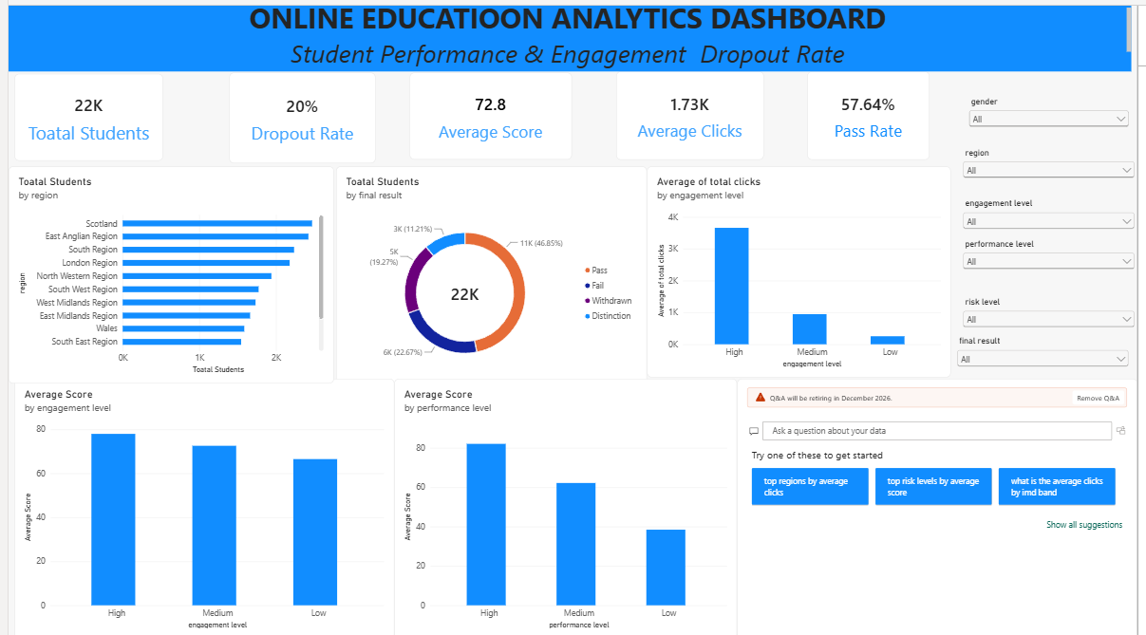

1.Major Outcomes from the Dashboard
The dashboard includes:
1 .KPI Cards
2. Interactive Charts
3.Performance Analysis
4.Engagement Analysis
5.Regional Analysis
6.Final Result Analysis
7.Interactive Slicers

- Total Students: The dashboard contains approximately 22K students, indicating a large online-learning student population.
- Dropout Rate: The overall dropout rate is 20%, showing that one-fifth of the students are recorded as dropouts.
- Average Student Performance: The overall average score is 72.8, indicating the general academic performance of students.
- Pass Rate: The overall pass rate is 57.64%, meaning more than half of the students achieved a passing result.
- Final Results: The largest group of students achieved a Pass (approximately 11K / 46.85%), followed by Fail (approximately 6K / 22.67%), Withdrawn (approximately 5K / 19.27%), and Distinction (approximately 3K / 11.21%).
- Engagement and Clicks: Students with High engagement have the highest average clicks at approximately 3.7K, compared with about 0.9K for Medium and 0.2K for Low engagement.
- Engagement and Performance: Average score is highest among students with High engagement (around 78), followed by Medium (around 72) and Low (around 66)
- Performance Levels: Students in the High performance level have an average score of about 82, compared with approximately 62 for Medium and 38 for Low, showing clear differences across performance levels.

